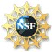
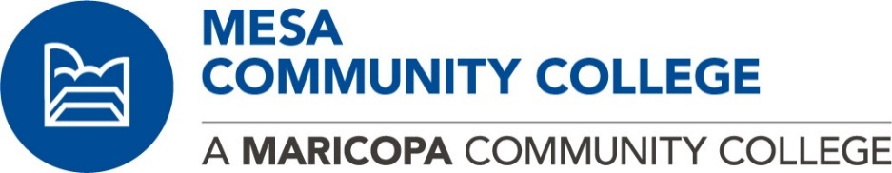

National Science Foundation
S-STEM Scholarship Application for Fall 2017

What is the Academic Success and Professional Development (ASAP) program?
Mesa Community College (MCC) seeks to recruit students who are pursuing degrees in the fields of Physical Science (Engineering etc.), Life Science (Biotechnology etc.), and Computer Science. Although we seek to increase the number of historically underrepresented students in these areas, all students who meet the following criteria are encouraged to apply and will be considered in the process. S-STEM scholarship recipients will receive financial support and be assigned to a faculty mentor who will: provide advising by creating an individual education plan, provide community learning/internship opportunities, and provide academic support to ensure satisfactory progress in their courses and goals.

Each scholarship recipient will receive a one-semester award of $600 to be distributed in Fall 2017.

How do I qualify for the S-STEM?
In order for a student to qualify for a scholarship award you must satisfy the following criteria:
S-STEM Qualifications
- Be U.S. Citizen, Permanent Resident, or Aliens admitted as Refugees
- Enrolled full-time student (12 or more hours)
- Be an entering freshman or sophomore at MCC
- Declared major in Physical Science, Life Science, or Computer Science
- Fall enrolled for MAT 151 or higher
- GPA 3.0
- Financial Need as established by FAFSA

“Only those with a lawful presence in the US may qualify for MCCCD scholarships or federal financial aid. Any information you provide about your legal status when you apply for financial aid or scholarships may be subject to mandatory reporting to federal immigration authorities under AZ law.”

What are the expectations of a S-STEM participant?
Each scholarship recipient is expected to:
- Participate in a student orientation.
- Meet with faculty mentor a minimum of 3 times during the semester
- Develop an individual education plan with mentor
- Maintain full-time status (12 or more hours) and cumulative GPA of 3.0

How do I get more information?

Please contact Prof. Jim Sizemore (jim.sizemore@mesacc.edu), Physical Science.

Application forms are available at the Physical Science Department (PS15; 480-461-7015). Completed applications must be returned to Prof. Sizemore by Friday, September 15, 2017, NOON.

1833 West Southern Avenue ∆ Mesa, Arizona 85202 ∆ (480) 461 - 7000
A M a r i c o p a C o m m u n i t y C o l l e g e

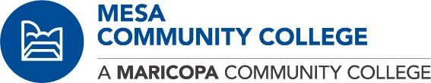
Fall 2017 NSF S-STEM Scholarship Application

Student Name: ___________________________ SID: _________ Address: ______________________________ Date of Birth: ____________________________
______________________________________________ Home Phone Number: _______________ City State Zip

E-mail: ______________________________ Cell Phone: _________________________ Cumulative GPA: ______________ Grade level: Freshman Sophomore Will you be a full time student for Fall 2017 semester (minimum 12 credit hours) Yes No Are you a: United States Citizen Permanent Resident Alien Refugee alien
Major: Physical Science (Engineering, Astronomy, Chemistry, Geology, and Physics)
Life Science (Anatomy & Physiology, Biology, and Biotechnology)
Computer Science (not CIS)

What field?

University you are planning to transfer to: __________________

If you receive this scholarship how many hours will you be working?
NSF Required Demographic Information
Gender:
Female
Male
Do you have any documented disabilities:
Yes
No
Ethnic Background
Native American
Asian or Pacific Islander
Hispanic
African American
Caucasian
Other:

In order to have a complete application packet the following must be included:

Application
A one page personal statement that includes the following:
- Personal Statement describing academic/career goals, reasons for the goals, specific objectives to meet the goals, the perceived value of the S-STEM ASAP scholarship program, academic and other accomplishments, special skills, community service, leadership potential, the applicant’s ability to overcome obstacles, family’s educational background.
- Preference is given for students who provides one letter of recommendation addressing student’s potential for success from an instructor or a high school teacher.
An unofficial transcript (note: For freshman students, a High School transcript may be submitted).

I certify that the information provided is accurate and correct to the best of my knowledge. If an award is made, I give Mesa Community College permission to release academic, financial, and/or any other necessary information as required by the National Science Foundation.
Signature: _______________________________ Date: _____________________

OFFICE USE ONLY

Date Received:
Physical Science, Life Science, or Computer Science Major
Completed & Signed Application
Personal Statement
One Letter of Recommendation
Transcripts Comments:

Awarded Not Awarded

Rationale:

Mentor: Mentor Signature:

Faculty Coordinator Signature:

1833 West Southern Avenue ∆ Mesa, Arizona 85202 ∆ (480) 461 - 7000
A M a r i c o p a C o m m u n i t y C o l l e g e

