THE VALLEY FOUNDATION
4729 E. SUNRISE DRIVE #307
TUCSON, AZ 85718
(520) 325-3390
FAX: (520) 325-3670
www.valleyfoundationaz.org
info@valleyfoundationaz.org

__________________________ __________________________ _________________________
Applicant Name Telephone Number E-mail Address

CHECKLIST:

1. Completed Application: (Faxes will not be accepted. We must receive the original.)
2. Current OFFICIAL transcripts from each high school and college attended:
  - If more than ten years have passed and the applicant is currently attending college, high school transcripts are not required.
  - Official transcripts must be requested from the institution and be sealed and stamped by the institution. If this seal is broken the transcripts are no longer considered official and will not be accepted.
  - Official transcripts may be submitted with your application package as long as they remain sealed and bear the institutions official transcript stamp.
3. Two Essays:
  - Personal statement (described in application under Essay Questions)
  - Essay chosen from list provided on application
4. Three letters of recommendation:
  - Must be addressed to the Valley Foundation
  - The letters of recommendation may be submitted with your application only if each is in an envelope sealed by the person providing the recommendation with their signature across the seal.
  - Otherwise the letters of recommendation must be sent directly to the Foundation by the person providing the recommendation. Please follow-up with those writing the letters to ensure that letters are sent in time to be received by the deadline.
5. Signed Authorization (final page of the application).

  - Applicant must be a United States citizen.
● Applicants can be graduating High School students, students
currently attending college or those returning to college.
● High School Applicants whose grade point average places them in the
top 5% of their class will not be considered.

COMPLETE APPLICATION PACKAGE MUST BE RECEIVED AT
4729 E. SUNRISE DRIVE, BOX #307 BY
5:00P.M. ON MARCH 3, 2017 TO BE CONSIDERED.
THE VALLEY FOUNDATION
4729 E. SUNRISE DRIVE #307
TUCSON, AZ 85718
(520) 325-3390
FAX: (520) 325-3670
www.valleyfoundationaz.org
info@valleyfoundationaz.org

SCHOLARSHIP APPLICATION

How did you hear about the Valley Foundation application? ___________________

Biographical Data

Name in Full______________________________________________________________ Male Female
(Please print or type) LAST FIRST MIDDLE

Home Address________________________________________________________________________
NUMBER & STREET

________________________________________________________________________________________________________
CITY STATE ZIP CODE TELEPHONE E-MAIL

Current School________________________________________________________________________

____________________________________________________________________________________
NUMBER & STREET CITY STATE ZIP CODE

Date of Birth______/______/______ _________________________________________________
MONTH DAY YEAR SOCIAL SECURITY NUMBER (**Optional, if awarded will require #)

U. S. citizen _______ _______ If a naturalized citizen, what was the country of your previous
YES NO citizenship and when was U.S. citizenship obtained?

__________________________________________________

Marital Status_____________ No. of Dependents________

Name of Closest Relative ________________________________________________________________

_____________________________________________________________________________________
NUMBER & STREET CITY STATE ZIP CODE

Personal Information

What is your career choice? ______________________________________________________________

What is your major in college? ____________________________________________________________

List those colleges to which you are applying. ________________________________________________

Have you ever been placed on probation, suspended from school or any program, or formally charged with a crime in a court of law?
______ _______
NO YES

If yes, please explain on a separate sheet and attach it to this application to provide the review board with a better understanding of the obstacles you have faced and how you have been able to overcome them.

List any scholastic distinctions or honors you have received. ____________________________________

_____________________________________________________________________________________

_____________________________________________________________________________________

_____________________________________________________________________________________

Describe any special skills or talents that you possess. _________________________________________

_____________________________________________________________________________________

_____________________________________________________________________________________

_______________________________________________________________________

Advanced Education Programs

Are you presently attending or have you previously attended any college or university? _____ _____
YES NO
List in descending order beginning with most recent college:

College Name | Address (city and state) | Term beginning  (mo. & yr.) | Term ending  (mo. & yr.) | No. of credits | GPA

Current official transcripts from these colleges must accompany this application.

High School Studies

A current official transcript from the high school you are attending or have attended must accompany this application. SAT/ACT scores are also required to be provided from your high school if applicable.

School, Athletic and Community Activities

If currently attending High School or recently graduated, please complete all tables below. If not, skip to community service/volunteer and employment.

In the table below, list your principle school-based extracurricular activities. Include activities such as the arts, sports, student government, clubs, speech and debate teams, and service projects. Indicate the nature of your participation and elected or appointed leadership positions held in each, or honors received. Please rank by number (1,2,3) to the left of the box those three activities which have been most significant to you.

School Activity |  | Grade level or year of participation |  |  |  | Approximate number of hours per week and weeks per year involved | Positions held or honors won

Community Service/Volunteer:

Activity Year of Participation

Employment: List in descending order beginning with most recent.

Company | Address | Position | Hrs./Wk | Dates of Employment
Financial Data
Please provide the financial information necessary to complete the following table – one for each school you are considering (sample on next page). University or college: _____________________________

 | Estimated Expenses per Academic Year:
School Expenses: | Tuition and Fees |  | $
 | Books and Supplies |  | $_________
 | Total School Expenses: |  |  |  | $
Housing Expenses: | Rent |  | $
 | Utilities |  | $
 | Household Supplies |  | $_________
 | Total Housing Expenses: |  |  |  | $
Living Expenses: | Meals |  | $
 | Entertainment |  | $_________
 | Total Living Expenses: |  |  |  | $
Vehicle Expenses: | Vehicle Payment |  | $
 | Vehicle Insurance |  | $
 | Gasoline/Maintenance |  | $_________
 | Total Vehicle Expense: |  |  |  | $
Personal Expenses: | Clothing |  | $
 | Personal Necessities |  | $_________
 | Total Personal Expenses: |  |  |  | $
Medical Expenses: | Medical Insurance |  | $
 | Medical not covered by Insurance |  | $_________
 | Total Medical Expenses: |  |  |  | $
Miscellaneous Expenses (List) |  |  | $
 |  |  | $_________
 | Total Miscellaneous Expenses: |  |  |  | $_________
 | Total Expenses per Academic Year: |  |  |  | $
 | Estimated Contributions per Academic Year:
Employment Income: |  |  | $
Savings Utilized: |  |  | $
Family Contribution: |  |  | $
 | Applied For | Received
Financial Aid: |  |  | $
Grants: |  |  | $
Waivers: |  |  | $
Scholarships (List): |  |  | $
 |  |  | $
 |  |  | $
 | Total Contributions per Academic Year: |  |  |  | $_________
Total Contributions | Less Total Expenses for Academic Year: |  |  |  | $

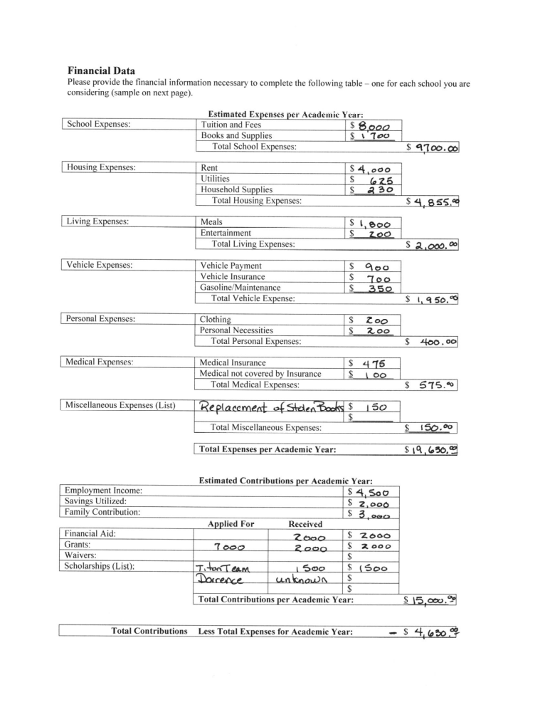

Essay Questions

The essays are an integral part of your application. Your response to the essays provides reviewers an opportunity to understand you better. Reviewers are interested in your ideas and how you express yourself, and will consider the essays as evidence of your creativity, writing ability, and insight. Please type your response to the personal and selected essay and attach both of these essays to your application.

1) Grades, scores and letters of recommendation can only tell us so much about any applicant. Please
write a personal essay that will help us know you better. This could include describing the world you come from- for example, your family, community or school- and how your world has shaped your dreams and aspirations. Please do not use an essay previously used in school. Limit 500 words.

- Choose one of the following topics. Limit 200 words.

- “Honesty is the best policy, but honesty won’t get your friend free birthday cake at the diner.” Does society require constant honesty? Why is it (or why is it not) problematic to shift the truth in one’s favor, even if the lie is seemingly harmless to others? If we can be “conveniently honest”, what other virtues might we take more lightly? [University of Chicago]

- If you were given the ability to change one moment in your life, would you do so? Why or why not? If so, what moment would you change and why? [http://www.collegeboundacademy.com]

- Choose one quotation that defines who you are and explain why that quotation describes you so well. [http://www.collegeboundacademy.com]

- If you were to write the story of your life until now, what would you title it and why? [Emerson College; Boston, Massachusetts]

.

Reference

Letters of recommendation from instructors, counselors, employers or community members are a very pertinent part of the review process. A minimum of three letters of recommendation are required. These letters can be sent directly from the recommending party to The Valley Foundation, 4729 E. Sunrise Drive #307, Tucson, AZ 85718. If included with your application, they must be sealed in an envelope by the person who wrote it with their signature across the seal. Please list your references and their contact numbers in the spaces provided below.

1. _______________________ _____________
Name Telephone

2. _______________________ _____________
Name Telephone

3. _______________________ _____________
Name Telephone

Authorization

In accordance with the application process, we authorize The Valley Foundation to obtain from the high school, guidance counselor, teachers, and other appropriate sources, such credentials as may be required in connection with this application, including, but not limited to, course grades, scores on standardized tests, personal appraisals and medical information. We also waive all access to the credentials so collected which shall be considered confidential, in accordance with the Family Educational Rights and Privacy Act of 1974.

Student Signature _______________________________________________ Date __________________

Signature of Parent or Guardian ____________________________________ Date __________________
(if under 18)

