LiveScribe Smartpen Basic Tutorial
Things to know about your smart pen:
- It needs to be charged.  - How to: Simply use the USB cord provided and plug it in to your computer, the pen will automatically begin charging. | 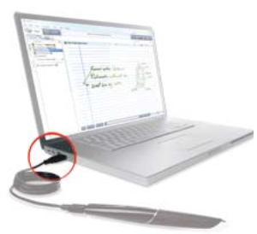
- It uses Ink  - How to replace them: To replace an ink cartridge, just use your fingers to grasp and pull out the old cartridge and insert a new one. | 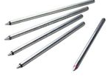

HOW TO RECORD A NEW SESSION:
Step 1: Power on  Power on your Live scribe smart pen | 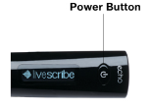 | Once the pen is powered on the display will come up and show Livescribe, then change to the main display screen which will show you that you are connected to wifi, the time, and the battery level.
Step 2: Begin Recording  Two ways to begin recording:  - Tapping Record button  - Using the Power Button |  | How to begin recording:  - Tapping the tip of your pen on the Record button located at the bottom of your Livescribe paper.  - Press and Hold power button for approximately 5 seconds or until display shows recording initiated.
Step 3: Recording Session |  | What to do now?  Your smart pen will begin to record audio. If you begin taking notes (on live scribe dot paper) the notes and audio become linked. Or your smart pen can simply record audio notes.
Step 4: Ending Recording  Three ways to end Recording:  - Tapping Stop button  - Turn Power off  - Using the Nav Plus | 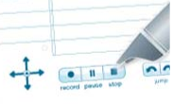 | How to end recording:  - Tap the Stop button located at the bottom of your Livescribe dot paper  - Turn power off, by pressing power button  - Using the Nav Plus: single tap to the center, and a single tap on the right arrow

