FIRE ACADEMY

APPLICATION AND INFORMATION PACKET

SPRING 2018

Submit (complete and incomplete) applications before December 11th
Mandatory Information Meeting – Saturday, December 16th

MESA COMMUNITY COLLEGE

FIRE ACADEMY CHECKLIST:

___ Submit Application and documentation
(Complete or Incomplete – See pages 5-8)
On page 5 as requested, please fill out Name of College or Licensing Agency with the Date Completed or check In Progress if you are currently signed up for the prerequisite.

___ Registration after prerequisites are complete

___ Attend Information Meeting (See scheduled dates and times on page 3)

PACKET CONTENTS:

Course Descriptions, Prerequisites, Co-requisites & Estimated Expenses p. 2

Course Locations, Days/times, Application Submittal Info p. 3

Fire Academy Application p. 5

FSC102 Disclaimer and Assumption of Risk Statements p. 6

Risk & Release of Liability……………………………………………………………...p. 7&8

MESA COMMUNITY COLLEGE

FIRE ACADEMY APPLICATION
SPRING 2018
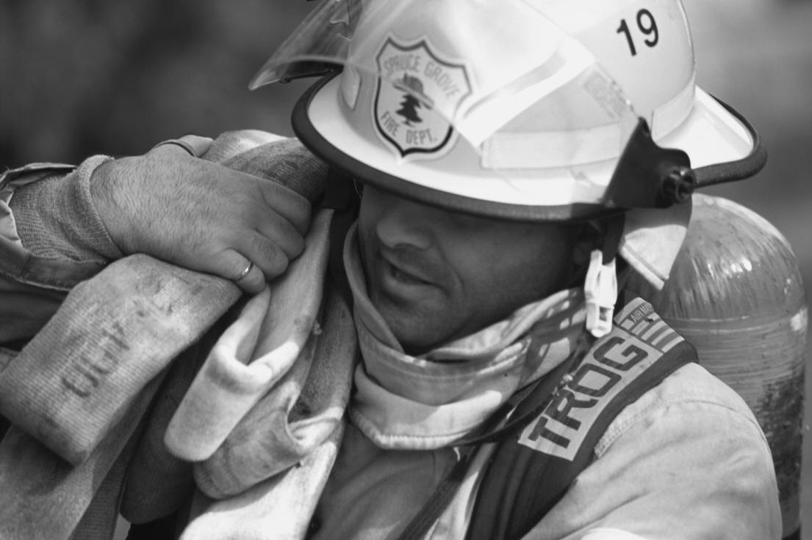

Mesa Community College offers a Certificate of Completion in Fire Operations. The certificate provides the opportunity for non-sponsored students to acquire a Certificate of Completion in Fire Operations in a college-based Fire Academy.

FSC102: Firefighting Operations (Fire Academy) covers firefighting skills, equipment, administrative policies, fire department operations and personnel policies that meet the standard for NFPA 1001. This course utilizes a blended learning component for enhanced learning. Students will be expected to complete online assignments and exams.

Prerequisites for FSC102 (Fire Academy class):
- Successful completion of EMT104 (with a grade of "C" or better in MCCCD system) ---
---OR --- current AZ State EMT – or Paramedic Certification
- Current CPR Certification at the Healthcare Provider Level.
- Successful completion of FSC105: Hazardous Materials/1st Responder (with a grade of “C” or better in MCCCD system) ---
--- OR --- ACFSE approved HazMat/1st Responder Certification
- Completion of FSC130: Fitness & Conditioning/CPAT with a passing grade within 9 months prior to acceptance ---
--- OR --- current passed CPAT within 9 months prior to the 1st day of class.
Co-requisite for FSC102: FSC134: Fitness & Conditioning/Firefighters (3 credits)
It is essential that Fire Academy students be able to perform a number of physical activities in the lab portion of the academy. At a minimum, students will be required to lift heavy equipment, stand several hours at a time and perform bending activities. The lab experience also places students under considerable mental and emotional stress as they undertake responsibilities and duties in firefighting. Individuals should give careful consideration to mental and physical demands of the program prior to applying.

MCC Estimated Student Expenses
FSC102 and FSC134 (subject to change)
MCC
1. Registration Fee | $ 15.00 |  | Uniforms (approximate) | $ 200.00
2. FSC102 Tuition 11 cr. @ $86/cr. | $ 946.00 |  | Turnout Rental (approximate) | $ 664.00
3. FSC134 Tuition 3 cr.@ $86/cr. | $ 258.00
4. FSC102 Course Fee | $ 300.00
5. FSC134 Course Fee | $ 30.00
 | $1,549.00

SPRING 2018 FIRE ACADEMY
COURSES, LOCATIONS, DAYS/TIMES
January 22nd – May 11th 2018

Mesa Public Safety Training Facility
3260 North 40th Street
Mesa, AZ 85215

MESA COMMUNITY COLLEGE
FSC102 – Fire Operations | FSC134 – Fitness for Firefighters  (Co-requisite for FSC102)
FSC102: Fire Operations (11 credits)  Monday (Skills 9:30am-3:00pm)  Wednesday (Classroom 9:30am-1:00pm)  Friday (Classroom 9:30am-1:00pm)  *Skills scheduled day is subject to change according to Mesa’s training facilities schedule. | FSC134: Fitness for Firefighters (3 Credits)  Monday (8:00am-9:20am)  Wednesday (8:00am-9:20am)  Friday (8:00am-9:20am)  *Skills scheduled day is subject to change  according to Mesa’s training facilities schedule.
MCC Applications are to be submitted to:
Fire Science/EMT Department
145 N. Centennial Way, 4th Floor
Mesa, AZ 85201
Attn: Deana Bright (480-461-6300)
deana.bright@mesacc.edu

Submit (complete or incomplete) applications before December 11th

http://www.mesacc.edu/departments/fire-science-emt

Applications can be submitted while you are in progress. After prerequisites are complete, it is the students’ responsibility to come into the office to get registered by availability of the classes. Registration is on a first come – first serve basis by complete packets. Attending the Information Meeting on the date listed below is required. At the meeting you will receive information for the Fire Academy, Turnout Rental, and Uniforms.

Mandatory Information Meeting

Saturday, December 16th 2018 (9:00am - 11:00am)

Meeting will be held at the Mesa Public Safety Training Facility
3260 N 40th St, Mesa AZ 85215

(More information will be sent to applicants prior to the meeting)

MESA COMMUNITY COLLEGE Office Use Only
FIRE ACADEMY APPLICATION – SPRING 2018 Date Submitted ________
Received By __________

Name: Student ID#:
Last First Middle
Mailing Address:
City: State: Zip:
Phone #1: Phone #2:
E-mail Address:
Do you hold a current AZ state EMT certification? No: ___ Yes: ___ Certification #: __________________
List other Academies you are applying for: _________________________________________________________
____________________________________________________________________________________

PREREQUISITES
Attach unofficial copies of your transcripts if within MCCCD (including courses in progress)
Forward official transcripts to the Records Department if courses outside of MCCCD

College Course  or  Certification Issued | Name of College or Licensing Agency | Date Course  Completed or  Date Lic. Issued | Courses  in  Progress
EMT104 (with grade "C" or better in MCCCD system)  or – Current AZ State EMT-B Certification  or – Current AZ State EMT-Paramedic Certification |  | Attach Copy (Unofficial transcripts or certification)
FSC105: HazMat/1st Responder (w/grade of "C" or better  in MCCCD system)  or – ACFSE approved HazMat/1st Responder Certification |  | Attach Copy (Unofficial transcripts or certification)
FSC130: Fitness & Conditioning/CPAT (with a  (passing grade within 9 mos. prior to acceptance)  or -- Current passed CPAT within 9 months prior to  1st day of class. (Attach copy of front & back card) |  | Attach Copy
Current CPR Certification at the Healthcare Provider Level  (Attach copy of front & back of CPR card) |  | Attach Copy

***********************************************************************************
EDUCATIONAL BACKGROUND:
a. High School Graduation Date: High School Name: City/State:
G.E.D.: Year Completed: State:
b. Other Degrees, Educational, Courses, Certificates:
Degree, Course, Etc. | College or Sponsoring Agency | Date (Month/Year) | Credits, CEU's, or  Hours Earned

c. Have you ever attended a Fire Academy? Yes: No:
School Name & Location:
Do you hold a current License (or have had FFI or FFII)? Yes: No:
If yes, license #: where issued:
State Year Active or Inactive
Have you ever had a Fire Fighter Certificate suspended? Yes: No:
Have you ever been released/withdrawn from a Fire Academy? Yes: No:
Have you ever initiated a withdrawal from a Fire Academy? Yes: No:

I CERTIFY THAT THE ABOVE ANSWERS ARE TRUE, CORRECT, AND COMPLETE:

_______________________________________ _________________________
Signature of Student Date
MESA COMMUNITY COLLEGE
FSC102: FIRE OPERATIONS (FIRE ACADEMY)

THESE STATEMENTS WILL BECOME PART OF YOUR PERMANENT RECORD.

##################################################################################################

FIRE ACADEMY ASSUMPTION OF RISK AND HOLD HARMLESS

In the Fire Academy, the student will perform under hazardous conditions. Students will be exposed to extreme heat, adverse environmental conditions and dangerous equipment. The instructors will provide adequate instruction for operating under such conditions and holds the student responsible for properly following instructions.

The student in the Fire Academy must participate in lifting heavy cartons and objects. The student certifies that they are in good physical and mental health and are able to participate in heavy lifting.

I HAVE READ THIS DISCLAIMER HEREBY ASSUMING ALL RISK AND HOLD HARMLESS THE FACULTY, STAFF AND ADMINISTRATION OF MCCCD/MCC.

Signature Date:

##################################################################################################

FIRE ACADEMY DISCLAIMER

Your admission to the Mesa Community College Fire Academy is no guarantee that you will become certified as a firefighter. Further, completion of the program is not the sole criterion for obtaining certification as a firefighter in Arizona. Upon successful completion of course curriculum, exams, and practical skills assessments, the student may apply for a college Certificate of Completion in Fire Operations. Students who successfully complete the FSC 102 course with a minimum passing grade of 80% will be recommended to the Arizona Center for Fire Service Excellence (ACFSE) for Firefighter I/I I certification testing. Students will receive the Arizona Firefighter I/II Certification upon successful completion of the Arizona Center for Fire Service Excellence certification written and practical exams.

I HAVE READ AND UNDERSTAND THE FIRE ADADEMY DISCLAIMER.

Signature Date:

##################################################################################################

PLEASE SIGN AND SUBMIT THIS PAGE WITH YOUR APPLICATION

Mesa Community College does not discriminate on the basis of color, national origin, sex, handicap, or age in application, participation, access, and treatment of persons in instructional employment programs and activities.

Mesa Community College will take steps to ensure that the lack of English language skills will not be a barrier to admission and participation in vocational educational programs.

MARICOPA COUNTY COMMUNITY COLLEGE DISTRICT
2411 W e s t 14 t h St r e e t , T e m p e , A Z 8 5 2 8 1 - 6942
GENERAL ASSUMPTION OF RISK & RELEASE OF LIABILITY
For Students

Caution: This is a release of legal rights. Read and understand it before signing.

The Maricopa County Community College District is a public educational institution. References to College ("College") include all of the Colleges within the Maricopa County Community College District ("MCCCD"), its officers, officials, employees, volunteers, students, agents, and assigns.

I ______________________ , freely choose to participate in the MCC Fire Operations/Fire Academy (henceforth referred to as the “Program”). In consideration of my participation in this Program, I agree as follows:

RISKS INVOLVED IN PROGRAM: (Specific dangers endemic in this Program’s activity.)

Activity in the program is represented by NFPA standards. Hazardous, dangerous, and physically demanding operations performed in the program include, but are not limited to:

(1) Performing fire-fighting tasks (e.g., hoseline operations, extensive crawling, lifting and carrying heavy objects, ventilating roofs or walls using power or hand tools, forcible entry, etc.), rescue operations, and other emergency response actions under stressful conditions while wearing PPE and SCBA, including working in extremely hot or cold environments for prolonged time periods.
(2) Wearing an SCBA, which includes a demand valve-type positive pressure facepiece or HEPA filter masks, which requires the ability to tolerate increased respiratory workloads.
(3) Exposure to toxic fumes, irritants, particulates, biological (infectious) and nonbiological hazards, and/or heated gases, despite the use of PPE including SCBA.
(4) Depending on the local jurisdiction, climbing 6 or more flights of stairs while wearing fire protective
ensemble weighing at least 50 lb or more and carrying equipment/tools weighing an additional 20 to 40 lb. (5) Wearing fire protective ensemble that is encapsulating and insulated. Wearing this clothing will result in significant fluid loss that frequently progresses to clinical dehydration and can elevate core temperature to levels exceeding 102.2°F (39°C).
(6) Searching, finding, and rescue-dragging or carrying victims ranging from newborns up to adults weighing over 200 lb to safety despite hazardous conditions and low visibility.
(7) Advancing water-filled hoselines up to 2.5 in. in diameter from fire apparatus to occupancy
(approximately 150 ft); can involve negotiating multiple flights of stairs, ladders, and other obstacles.
(8) Climbing ladders, operating from heights, walking or crawling in the dark along narrow and uneven surfaces, and operating in proximity to electrical power lines and/or other hazards.
(9) Unpredictable emergency requirements for prolonged periods of extreme physical exertion without benefit of warm-up, scheduled rest periods, meals, access to medication(s), or hydration.
(10) Operating fire apparatus or other vehicles in an emergency mode with emergency lights and sirens.
(11) Critical, time-sensitive, complex problem solving during physical exertion in stressful, hazardous environments (including hot, dark, tightly enclosed spaces), further aggravated by fatigue, flashing lights, sirens, and other distractions.
(12) Ability to communicate (give and comprehend verbal orders) while wearing PPE and SCBA under
conditions of high background noise, poor visibility, and drenching from hoselines and/or fixed protection systems (sprinklers).
(13) Functioning as an integral component of a team, where sudden incapacitation of a member can result
in mission failure or in risk of injury or death to civilians or other team members (e.g., two in, two out as described in NFPA 1500).

MC-AORROL-GEN (03/07/11) PAGE 1 of 2

HEALTH AND SAFETY: I have been advised to consult with a medical doctor with regard to my personal medical needs. I state that there are no health-related reasons or problems that preclude or restrict my participation in this Program. I have obtained the required immunizations, if any.

I recognize that College is not obligated to attend to any of my medical or medication needs, and I assume all risk and responsibility therefore. In case of a medical emergency occurring during my participation in this Program, I authorize in advance the representative of the College to secure whatever treatment is necessary, including the administration of an anesthetic and surgery. College may (but is not obligated to) take any actions it considers to be warranted under the circumstances regarding my health and safety. Such actions do not create a special relationship between the MCCCD and me. I release the MCCCD, its officers, officials, employees, volunteers, students, agents and assigns from all liability for any bodily injury or damage I sustain as a result of any medical care that I receive resulting from my participation in Program, as well as any medical treatment decision or recommendation made by an employee or agent of the MCCCD. I agree to pay all expenses relating thereto and release College from any liability for any actions.

ASSUMPTION OF RISK AND RELEASE OF LIABILITY: Knowing the risks described above, and in voluntary consideration of being permitted to participate in the Program, I agree to release, indemnify, and defend College and their officials, officers, employees, agents, volunteers, sponsors, and students from and against any claim which I, the participant, my parents or legal guardian or any other person may have for any losses, damages or injuries arising out of or in connection with my participation in this Program.

SIGNATURE: I indicate that by my signature below that I have read the terms and conditions of participation and agree to abide by them. I have carefully read this Release Form and acknowledge that I understand it. No representation, statements, or inducements, oral or written, apart from the foregoing written statement, have been made. This Release Form shall be governed by the laws of the State of Arizona which shall be the forum for any lawsuits filed under or incident to this Release Form or to the Program. If any portion of this Release Form is held invalid, the rest of the document shall continue in full force and effect.

____________________________
Signature of Program Participant Date

____________________________
Signature of Parent or Legal Guardian (if student is a minor) Date

MC-AORROL-GEN (03/07/11) PAGE 2 of 2

