EMT104 Checklist – Spring 2018

The following items are prerequisites to enroll in EMT104 at Mesa Community College.
Incomplete packets will not be accepted. Student is responsible for photocopying documentation.
Keep a copy of the packet “for your records”- we do not return paperwork you turn in.

- Signed copy of Student Contract (See Packet)
- EMT104 Information Sheet (See Packet)
- Photocopy of Driver’s License or State Photo ID
- Photocopy of Reading Assessment Test
(Requirements - See Packet - #3 on page 2)

- Photocopy of Healthcare Provider level CPR Certification
(Acceptable cards and levels – See Packet - #4 on page 3 or register in current EMT101 class)

Spring Semester - 2018
EMT104 Classes (9 Credits) – Classes scheduled 1/13/18 – 5/11/18)
Day Classes |  |  | Night Classes |  |  | Weekend Class
(Mon/Wed) 9:00am – 1:30pm |  |  | (Mon/Wed) 5:00pm – 9:30pm |  |  | (Sat) 8:00am – 5:00pm
(Tue/Thu) 9:00am – 1:30pm |  |  | (Tue/Thu) 5:00pm – 9:30pm
EMT104AB Classes (.5 Credit) - (1 Day class 9:00am – 6:00pm)
Fri - 4/6 | Sat - 4/7 | Fri - 4/13 |  | Sat – 4/14 | Thu – 4/19 |  | Fri – 4/20 | Sat – 4/21

Before Registering For EMT104 and EMT104AB:
You will need to be registered as a MCC student. Visit the Admissions & Records Office on the main campus or log on to http://www.mesacc.edu.

To search for EMT104 and EMT104AB classes online:
Log onto www.mesacc.edu / click on class schedules / Enter keyword EMT and click search

REGISTRATION
Please deliver completed packets to:
Mesa Community College (Dobson & Southern Campus) EMT / Fire Science Department
1833 W Southern Ave 145 N. Centennial Way
Building ES 39 4th Floor
Mesa AZ 85202 Mesa AZ 85201

Dear EMT Student,

Welcome to the Mesa Community College EMT training program. Our goal is to provide you with the highest level of education in an enjoyable learning atmosphere. In order for you to be eligible to begin EMT training you must first satisfy the requirements of the Arizona Department of Health Services. The following requirements are mandatory and require documentation to ensure compliance. All students must turn in their completed documentation to the Dobson & Southern Campus (1833 W Southern Ave – Building ES 39) or the EMT/Fire Science Office at the Downtown Center (145 N. Centennial Way, 4th Floor) during the normal business hours, no appointment is necessary. No copies will be made in our office. It is your responsibility to bring a completed packet ready to turn in.
Once we receive your completed documents we will register you in EMT104 and EMT104AB for the current semester. If you have any questions, please call our office at (480)461-7619 or (480)461-6300.

Cost For EMT104 & EMT104AB Classes

In-State Tuition $ 774
Course Fees $ 160
Registration Fee $ 15
EMT104AB $ 93
Total $1042

The following must be provided at the time of registration for EMT104. If any documentation is incomplete you will not be given permission for registration.

- You must have a signed copy of the Student Contract.

- You must be 18 years of age before you can take the NREMT Exam within one year from end of program.

- You must take the reading assessment test and attain a minimum score of 74 on the ACCU PLACER within 2 years or have tested “Exempt.” We will also accept AIMS score of 720 or higher, Composite Score of min. of 93 on the PSAT, Composite Score min. of 930 on the SAT within 2 years or have an Associate Degree or higher prior to enrolling.

The tests are given at the MCC testing center on the main campus at 1833 W. Southern Ave., Mesa, AZ, (480)461-7480 or the Red Mountain Campus at 7110 E. McKellips Rd, Mesa, AZ, 85207 (480)654-7200.

Testing is done Monday through Thursday from 8am to 5pm and Friday from 10am to 4pm (Closed on Friday’s for summer). We will need a copy of your test results or degree.

- You must be CPR certified by one of the following institutions and at the corresponding level. All training must meet the 2015 guidelines or be registered for the EMT101 class the week prior to the first day of the EMT104 class. (You may get registered for the EMT101 when you come in to register for the EMT104 class).

*CPR Certification must be maintained throughout the course and during National Registry testing.

Issuer: Level of Training:

American Heart Association…………………………………..Healthcare provider or BLS Provider

American Red Cross ………………………………………...Professional Rescuer

American Safety & Health Institute…………………..............CPR Pro / BLS

Green Cross or NSC …………………………………….…..Professional Rescuer

Military Training Network……………………………..….......“Meets AHA 2015 guidelines
for “Health Care Providers”

If you do not have one of the CPR cards with the correct level which is listed above you can get registered in one of the following EMT101 classes which is recommended by the program director. These classes will be held the week before the EMT104 begins. When you bring your packet into the office for registration, we will also register you for one of the EMT101 classes.

Spring 2018
EMT101 Classes (.5 Credit) – (One Day Class)
Sat, Jan 6 | Wed, Jan 10 | Wed, Jan 10 | Thu, Jan 11 | Thu, Jan 11
9:00a –4:00p | 9:00a – 3:30p | 4:00p – 10:00p | 9:00a – 3:30p | 4:00p – 10:00p

- You must register for EMT104AB class at the same time you are registering for the EMT104 class. Must complete the program as a P/Z (Pass/Fail), attend the complete class, and meet all competencies.

- It is the responsibility of the student to check their Mesa Community College E-mail after registration for any possible changes that may occur such as class cancelation or being dropped for any reason.

The above requirements are for your safety and well-being. Compliance will require some effort on your part. Please remember to include copies of all your required documentation to the EMT/Fire Science office. No partial packets will be accepted. Please call (480) 461-6300 or (480) 461-7619 at the EMT/ Fire Science office if you have any questions. Thank you for your cooperation and we look forward to seeing you.

Sincerely,
Christopher M. Burrows
EMT – Occupational Program Director
Mesa Community College

Clinical Information

Applied Practical Studies for Emergency Medical Technology - EMT104AB (Total Patient Management Clinical)

(Must Register for and complete the program as a P/Z (Pass/Fail). Attend all of class and meet all competencies.)
Applied Practical Studies For Emergency Medical Technology (EMT104AB) 0.5 Credits:
Simulation of actual emergency responses, with practical application of techniques and skills covered in EMT curricula. Scenario based learning applied to the techniques of emergency medical care in accordance with national and state curriculum. Practical application of anatomy, physiology, patient assessment, and treatment of medically or traumatically compromised patients, special hazards and medical operations. Also includes patient-assisted medication administration, semi-automatic external defibrillator and blood glucose monitoring. Students function in outside, scenario based environment. Co-requisites: EMT104, or permission of Instructor.
Dress code will be your grey EMT program shirt, Dark blue long pants (Dockers type) and black shoes. You are expected to behave in a courteous and respectful manner and represent the MCC program in a positive way. Tobacco use is prohibited while attending the clinical.
You will get registered for EMT104AB class at same time you get registered for EMT104.

Student Dress Code

While in class, students should be prepared to participate in practical skills. This may include bending, kneeling, light lifting and close contact with fellow students. Students should dress reflecting the industries professional demeanor, with comfort in mind.
Due to the physical nature of this class appropriate dress is required.

* Long pants: Jean or docker style pants. The pants must fit and not slide down and show any portion of underwear or gluteal area. If the pants are loose fitting, a belt must be worn. The pants need to be in good repair without holes or dangling material of any kind.

* The department will provide a grey shirts must be worn in class and for clinical. The MCC Fire and EMS Department produces a department t-shirt (black) that can be worn in class but may not be worn at clinical experience. You will be given information about ordering your uniform shirts the first day of class.

* Closed-toe shoes: Tennis shoes, work boots, snug fitting work shoes, or any other closed-toe shoe that will not slip off the foot are allowed (laces must be tied). Flip-flops, sandals or any shoe that does not fully cover the foot are not allowed.

Emergency Medical Technology
Certificate of Completion (CCL) Advisement Check Sheet

This Certificate of Completion (CCL) in Emergency Medical Technology program includes techniques of emergency care, stabilization, and immobilization of victims of illness and injury. Recognition and documentation of signs and symptoms of illness and injury, intervention, and evaluation of the intervention, techniques for assessment, administration of oxygen, use of specific immobilization devices, and preparation for transportation are other areas in the program.

Program Notes:
☑ Students must earn a grade of C or better in all required courses
☑ Student may complete both ENG101 and CRE101 as an alternative to CRE111 or reading exemption
☑ For assistance with course selection, contact an Academic Advisor or the Program Director

MCC Registration & Enrollment Map
1833 W Southern Ave, Building ES 39
Mesa, Arizona 85202

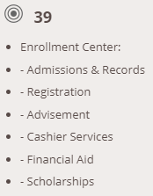

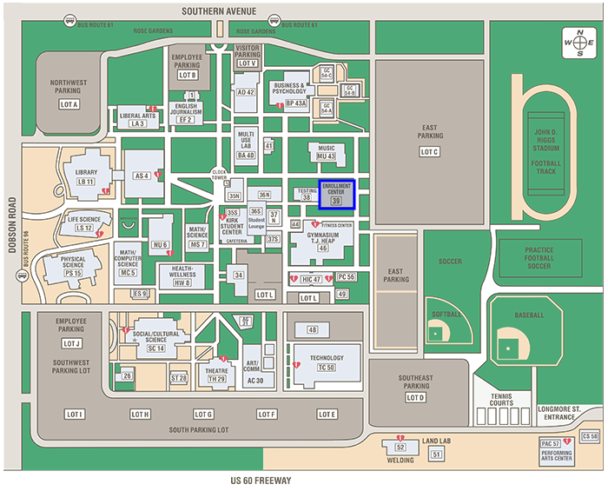

EMT Student Contract

I _________________________________________ by signing this contract, agree with the following:

1) My MCC 8-Digit Student ID # is _____________________

2) You must be 18 years of age before you can take NREMT Exam within one year from end of program.

3) I have submitted the required documentation for the reading assessment test or proof of degree.

4) I am currently certified in CPR at the “Health Care Provider” level by the American Heart Association or “Professional Rescuer” level by the American Red Cross or “CPR Pro” by the American Safety and Health Institute (ASHI) or registered for the EMT101 class prior to the first day of EMT104 class.

5) I will register for EMT104AB when I register for the EMT104 class.

6) I have received a copy of the policies and procedures of the MCC EMT-basic Training Program and I understand them fully.

7) I understand that I may not miss any more than a cumulative of 12 hours of the entire MCC EMT-basic Training Program. If for any reason and that I may be dropped from the course and forfeit any tuition or fees paid if I violate this rule. No exceptions.

8) I understand that I must receive a minimum 70% overall grade in the class, complete EMT104AB, complete final exam (200 questions) with a 75% or greater and pass the skill stations; to be eligible to take the National Registry exam for certification.

9) I understand that if I get dropped from the class for any reason, re-enrollment will be based on the availability of open seats.

10) I understand it is my (the students) responsibility to check my Mesa Community College E-mail after registration for any possible changes that may occur such as class cancelation or being dropped for non-payment.

Signature_______________________________________________ Date_________________

E-Mail Address________________________________ Phone Number: _____________________

Last 4 Digits of SS#_______________

Emergency Medical Technology
EMT104 Information Sheet

Name: ____________________________________ SID #: ________________
Phone: _______________________ Email: _______________________________
What is the highest score on the Accuplacer reading test? __________
- How many times have you taken the Accuplacer reading test in the last 12 months? __________
- Have you taken CRE101 ______ ENG101 _______ ENG _______ CRE111 _______
Have you completed any other college classes? YES ______ NO ______
- If yes, attach copy of classes or include in narrative.
Did you take EMT101 or go to a training center for CPR certification? ________________________
- Month and Year you received your CPR card _____________
Narrative (optional). If you would like (it is not required), provide any additional information you would like for the EMT Department, such as classes you have already taken to prepare for EMT or any other allied health programs:

_________________________________________________________________________________________________________________________________________________________________________________________________________________________________________________________________________________________________________________________________________________________________________________________________________________________________________________________________________________________________________________________________________________________________________________________________________

This form and all requested documents can be taken to the Dobson & Southern Campus (1833 W Southern Ave – Building ES 39) or EMT/Fire Science Office at the Downtown Center (145 N. Centennial Way, 4th Floor)

