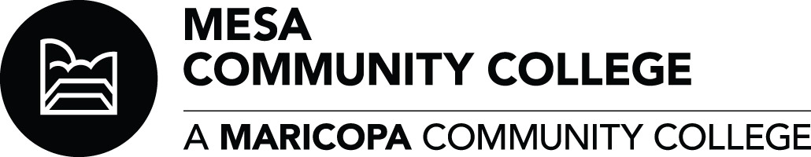
Program Review Executive Summary
The Executive Summary document is only for accredited programs who have a self-study due the same year as program review. In those cases, the shorter Executive Summary form replaces the regular Program Review Template.
OCCUPATIONAL PROGRAM DESCRIPTION

Carl D. Perkins definition of Career and Technical Education:
- Offers a sequence of courses
- Includes competency-based applied learning that contributes to the academic knowledge, higher-order reasoning and problem-solving skills, work attitudes, general employability skills, technical skills, and occupation-specific skills, and knowledge of all aspects of an industry, including entrepreneurship, of an individual

National Center for Education Statistics (NCES) Integrated Postsecondary Education Data System (IPEDS) definition of an Occupational Program:
- A program of study consisting of one or more courses, designed to provide the student with sufficient knowledge and skills to perform in a specific occupation

Alignment with the National Career Clusters Framework
- Aligns to 1 of 16 Career Clusters
- Within the identified Career Cluster, MCC program(s) of study align to one or more Career Pathways. Maintains a Plan of Study for each identified Career Pathway which demonstrates alignment with local secondary programs of study

REQUIRED OCCUPATIONAL PROGRAM ELEMENTS

Program Name:

Semester and Year:

Faculty Report Contributors/Authors:

Program Vision Statement:

Program Mission Statement:

Date of Last Program Advisory Review/Approval of Vision and Mission Statements:

Program Accreditation Information
Accreditor Name and web link | Status | Date of Expiration | Month of Annual Reporting

Advisory Meeting Dates and Attendance (past 3 years)

Date of Meeting | # of MCC attendees | # of Non-MCC attendees

CCTA Program Information (insert additional rows as needed)
https://asa.maricopa.edu/departments/center-for-curriculum-transfer-articulation/programs-degrees

Degree/Certificate Name | Major  Code | Award  Type | Total  Credits | CIP  Code | SOC Code(s) | Date of Program  Competency Update
Ex: Business Administration | 1234 | AAS | 60 | 11.0304 | 21-1243 | 01/18/2016

MCC Course Sequence (insert additional rows as needed)
If program courses are not sequenced, please contact the Curriculum and Scheduling Office for assistance in sequencing.

Degree/Certificate Name | Web link to Course Sequence on Program Page

National Career Clusters Framework
https://careertech.org/career-clusters
List the Career Cluster associated with the occupational program.

List the specific Career Pathways associated with the identified Career Cluster which are applicable to this occupational program.

Strategic Planning

SOAR analysis
The American Society for Quality currently advocates for strengths, opportunities, aspirations, results (SOAR) analysis. Use of a strengths, weaknesses, opportunities, threats (SWOT) analysis developed by Albert S. Humphrey in the 1960s is also acceptable.

Strengths

Opportunities or Weaknesses

Aspirations or Opportunities

Results or Threats

Maricopa Integrated Risk Assessment (MIRA)
The Maricopa Integrated Risk Assessment (MIRA) is a project that embraces a wider view of risk called Enterprise Risk Management (ERM). ERM enables employees to collaboratively identify, assess and manage future risks and opportunities. Learn more about MIRA: https://business.maricopa.edu/risk-management/mira/what-is-mira

As a result of conducting this Program Review, are there any risks that were identified as in need of further assessment and/or mitigation?

Program Plan
A Program Plan provides strategic academic direction for the next 3 years. This plan provides annual initiatives or goals to better position the program to promote student success, support teaching and learning, meet industry needs, and proactively capitalize on those opportunities identified as a result of conducting the review.

At the request of your department, a Program Plan may be entered into the Department Planning system available through IE. If requested by your Department, these Program Plans provide strategic academic direction for the next 3 years. This plan provides annual initiatives or goals to better position the program to promote student success, support teaching and learning, meet industry needs, and proactively capitalize on those opportunities identified as a result of conducting the review.

Year 1 Initiatives

Year 2 Initiatives

Year 3 Initiatives

